Static Import

In Java, static import concept is introduced in 1.5 version. With the help of static import, we can access the static members of a class directly without class name or any object. For Example: we always use sqrt() method of Math class by using Math class i.e. Math.sqrt(), but by using static import we can access sqrt() method directly.#According to SUN microSystem, it will improve the code readability and enhance coding. But according to the programming experts, it will lead to confusion and not good for programming. If there is no specific requirement then we should not go for static import.

// Java Program to illustrate
// calling of predefined methods
// with static import
import static java.lang.Math.*;
class Test2 {
public static void main(String[] args)
{
System.out.println(sqrt(4));
System.out.println(pow(2, 2));
System.out.println(abs(6.3));
}
}

// Java Program to illustrate
// calling of predefined methods
// without static import
class Example {
public static void main(String[] args)
{
System.out.println(Math.sqrt(4));
System.out.println(Math.pow(2, 2));
System.out.println(Math.abs(6.3));
}
}

Lambda
Lambda expressions are introduced in Java 8 and are touted to be the biggest feature of Java 8. Lambda expression facilitates functional programming, and simplifies the development a lot.
A lambda expression is characterized by the following syntax.

parameter -> expression body
Following are the important characteristics of a lambda expression.

Optional type declaration − No need to declare the type of a parameter. The compiler can inference the same from the value of the parameter.

Optional parenthesis around parameter − No need to declare a single parameter in parenthesis. For multiple parameters, parentheses are required.

Optional curly braces − No need to use curly braces in expression body if the body contains a single statement.

Optional return keyword − The compiler automatically returns the value if the body has a single expression to return the value. Curly braces are required to indicate that expression returns a value.

Types of Lambda Body
In Java, the lambda body is of two types.

1. A body with a single expression

() -> System.out.println("Lambdas are great");
This type of lambda body is known as the expression body.

2. A body that consists of a block of code.

() -> {
double pi = 3.1415;
return pi;
};
This type of the lambda body is known as a block body. The block body allows the lambda body to include multiple statements. These statements are enclosed inside the braces and you have to add a semi-colon after the braces.

import java.util.ArrayList;
import java.util.function.Consumer;

interface StringFunction{
String run(String str);
}

public class LambdaExample {

public static void printFormatted(String str,StringFunction format) {
String result=format.run(str);
System.out.println(result);
}
public static void main(String[] args) {

StringFunction ex=(s) -> s+"!";

StringFunction ask=(s) -> s+"?";

printFormatted("Hello", ex);
printFormatted("Hello", ask);
}}

import java.lang.FunctionalInterface;
// this is functional interface
@FunctionalInterface
interface MyInterface{
// abstract method
double getPiValue();
}
public class Main {
public static void main( String[] args ) {
// declare a reference to MyInterface
MyInterface ref;
// lambda expression
ref = () -> 3.1415;
System.out.println("Value of Pi = " + ref.getPiValue());
}
}

An enum type is a special data type that enables for a variable to be a set of predefined constants. The variable must be equal to one of the values that have been predefined for it. Common examples include compass directions (values of NORTH, SOUTH, EAST, and WEST) and the days of the week.

Because they are constants, the names of an enum type's fields are in uppercase letters.

Example 1: Java Enum
enum Size {
SMALL, MEDIUM, LARGE, EXTRALARGE
}

class Main {
public static void main(String[] args) {
System.out.println(Size.SMALL);
System.out.println(Size.MEDIUM);
}
}

Collections
The Collection in Java is a framework that provides an architecture to store and manipulate the group of objects.
Java Collections can achieve all the operations that you perform on a data such as searching, sorting, insertion, manipulation, and deletion.
Java Collection means a single unit of objects. Java Collection framework provides many interfaces (Set, List, Queue, Deque) and classes (ArrayList, Vector, LinkedList, PriorityQueue, HashSet, LinkedHashSet, TreeSet).

What is Collection in Java
A Collection represents a single unit of objects, i.e., a group.
What is a framework in Java
It provides readymade architecture.
It represents a set of classes and interfaces.
It is optional.
What is Collection framework
The Collection framework represents a unified architecture for storing and manipulating a group of objects. It has:
Interfaces and its implementations, i.e., classes
Algorithm
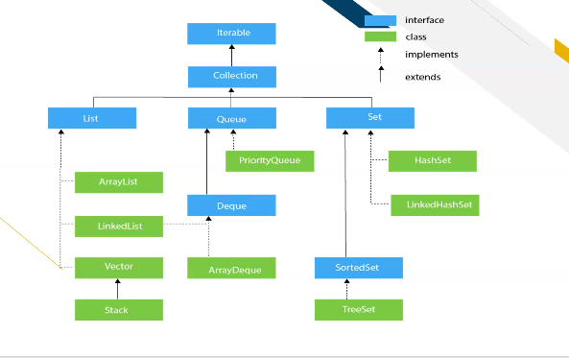
import java.util.Iterator;
import java.util.LinkedList;

public class CollectionExample {
public static void main(String[] args) {
LinkedList<String> al=new LinkedList<String>();
al.add("Anish");
al.add("tanish");
al.add("rupesh");
al.add("Paresh");

System.out.println(al);
Iterator<String> itr=al.iterator();

while(itr.hasNext()) {
System.out.println(itr.next());
}

}
}

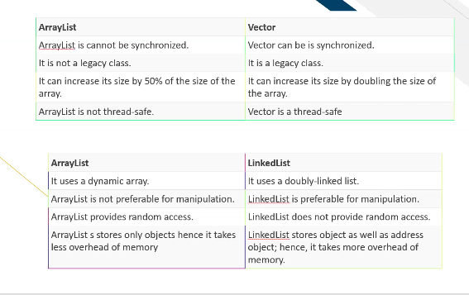
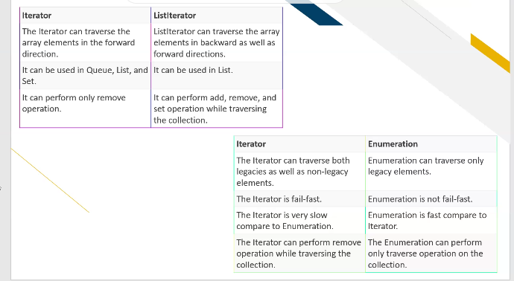
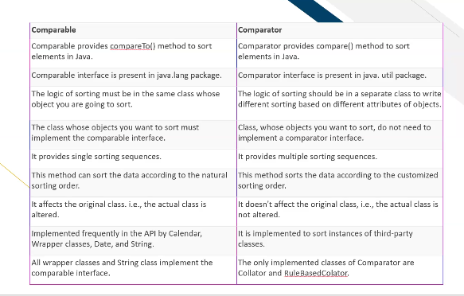
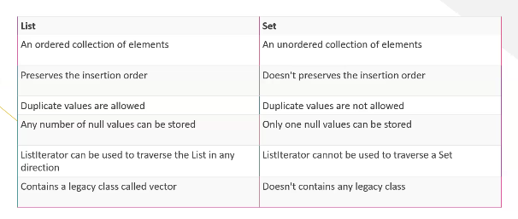
Fail-Safe. 1. Exception. Any changes in the collection, such as adding, removing and updating collection during a thread are iterating collection then Fail fast throw concurrent modification exception. The fail-safe collection doesn't throw exception.

